Quiz 2 Decision Tree Classification and Entropy/Information Gain Calculations
Use the following data set to determine which input feature should be the first to use to divide the data set (and grow the decision tree into two or more branches) based on the Maximum Information Gain Principle.
Type the needed calculations and arguments in the space below and rename the file using your name.
Discuss the reasons that decision tree is one of the most popular predictive analytics models for decision making.
A graph of the decision tree with proper information on all the nodes is required. The tree should be complete to have all leaf nodes of 100% purity.
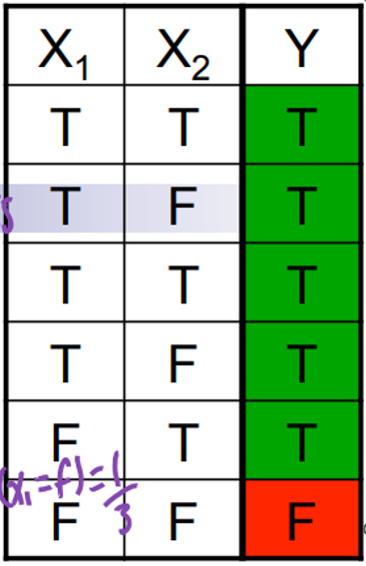

Quiz 2 Solution:
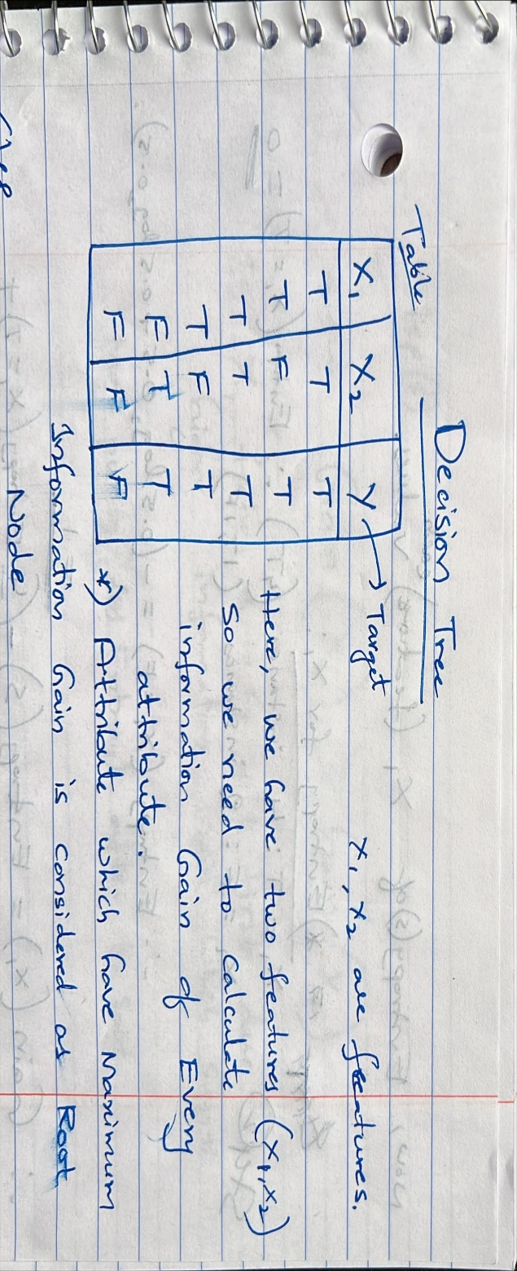
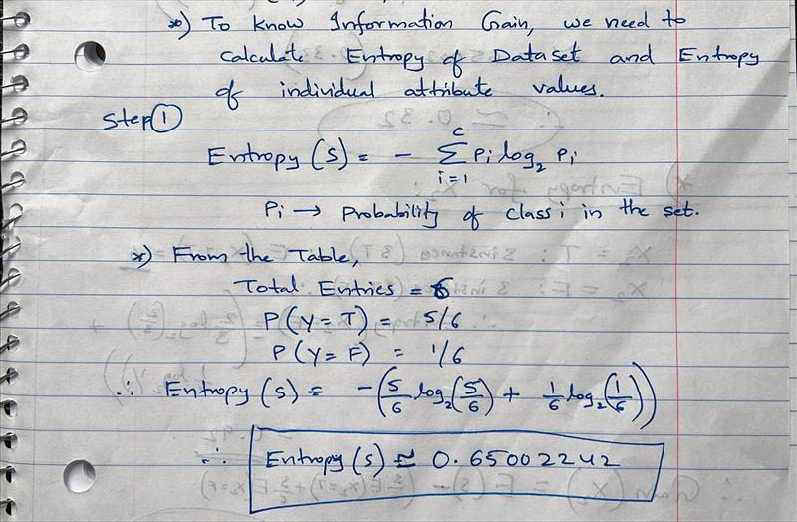

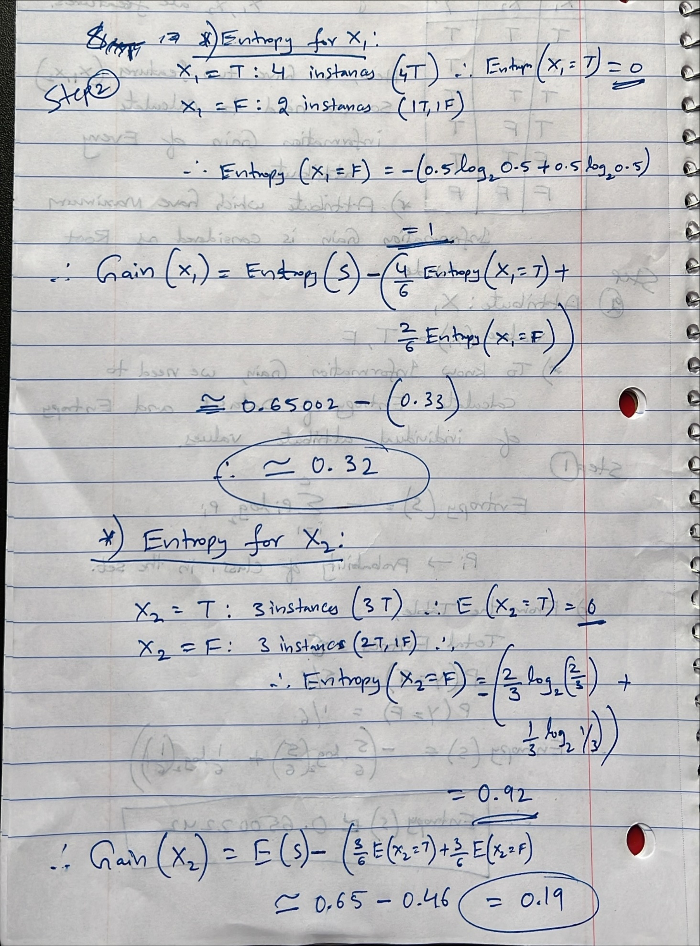

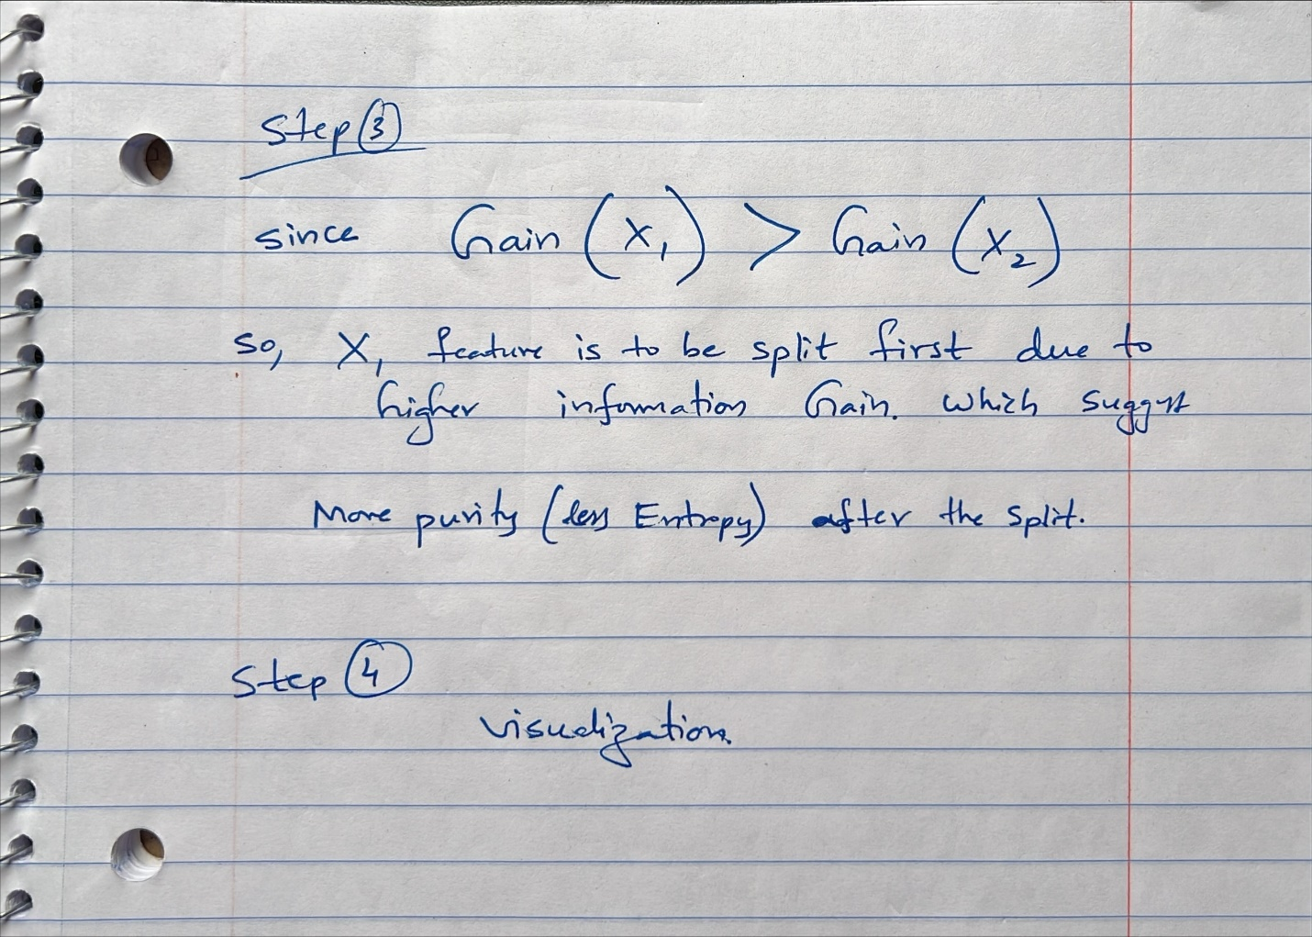

-------------------------------------------------------------------------------------------------------------------------------

Decision trees are popular for several reasons
- Interpretability: They can be easily understood and interpreted, making them accessible even to people without a deep understanding of statistics.
- Flexibility: They can handle both numerical and categorical data and perform well on large datasets.
- Non-parametric: They don’t require data to follow a particular distribution.

--------------------------------------------------------------------------
Code
!apt-get install graphviz -y
!pip install graphviz

from sklearn.tree import DecisionTreeClassifier, export_graphviz
import graphviz
import numpy as np

# Assuming your dataset is already loaded and prepared as X and Y
X = np.array([[1,1], [1,0], [1,1], [1,0], [0,1], [0,0]])
Y = np.array([1, 1, 1, 1, 1, 0]) # 1 for 'T', 0 for 'F'

# Train the decision tree with no maximum depth to ensure all leaves are pure
clf = DecisionTreeClassifier(criterion='entropy')
clf.fit(X, Y)

# Visualize the decision tree
dot_data = export_graphviz(clf, out_file=None, feature_names=['X1', 'X2'], class_names=['F', 'T'], filled=True)
graph = graphviz.Source(dot_data)
graph

Output:
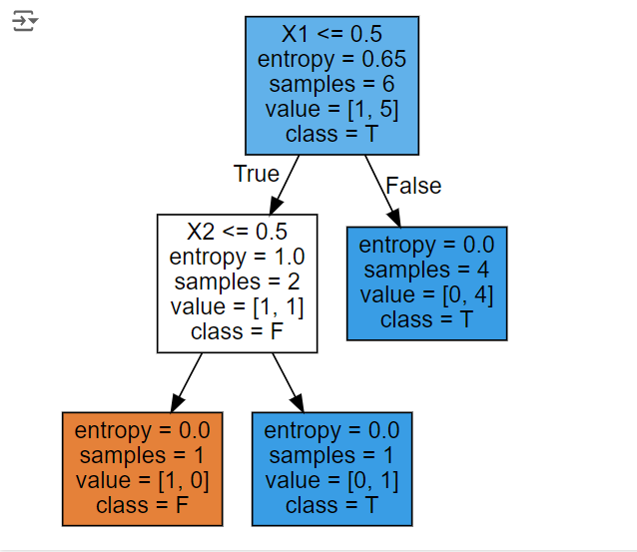

Note: To view the chart better, Please Paste the below GitHub link in https://nbviewer.org./

https://github.com/sairamvodnala/Assignments/blob/main/quiz2code.ipynb
*I did this quiz code in Google Collab to avoid installing Graphviz on the PC.

